THE AUXILIARY AWARDS $4,500 IN COLLEGE SCHOLARSHIPS

The Bethesda Auxiliary is pleased to announce the gift of 3 college scholarships to the following students:

The Junior Volunteer Scholarship was awarded to Sri Gottumukkala, a senior at Mason High School, who will attend The Ohio State University in the fall. Since May 2019, Sri has volunteered over 355 Hours as a greeter/escort at Bethesda North Hospital.

The Auxiliary awarded 2 scholarships to children of Auxiliary Members: Alana Lambers, daughter of Auxiliary member Stephanie Lambers is pursuing a degree in Speech Language Hearing Sciences at the University of Cincinnati and has worked with the Think First Program and Crosstown Concussion Crew.

Julia Tenbusch will be a sophomore at Otterbein University and is currently studying in Vietnam. She is the daughter of Auxiliary member Amy Tenbusch. Congratulations to our scholarship recipients and their families!

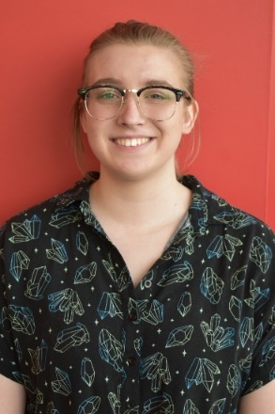
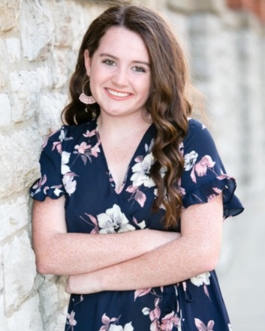
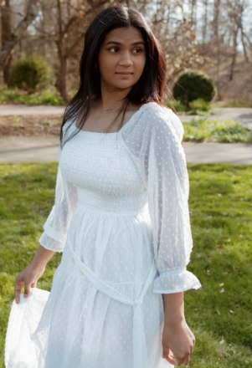

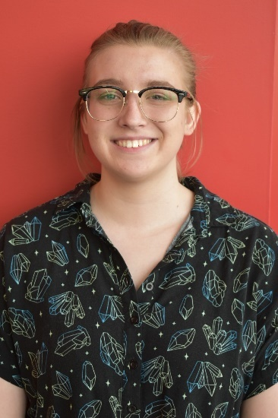
Sri Gottumukkala Alana Lambers Julia Tenbusch

