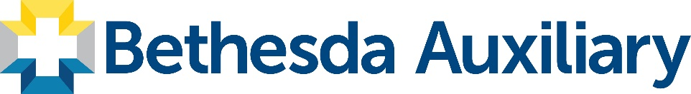
THE AUXILIARY OF BETHESDA HOSPITAL ANNOUNCES
$115,000 IN GRANTS

Over the last 60 years, the Auxiliary of Bethesda Hospital has provided over $3.5 million in funding for Bethesda Hospitals. This year, the Auxiliary is pleased to announce $115,000 in grants to Bethesda North Region projects.

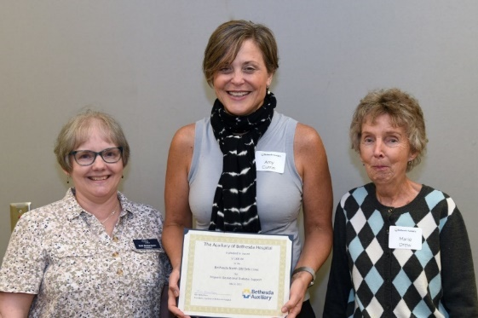
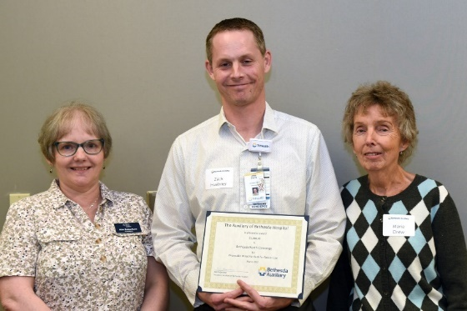
BETHESDA NORTH OB/GYN CLINIC. The Auxiliary is once again providing funds to address the needs of uninsured Hispanic women suffering from gestational diabetes. Gestational diabetes threatens the health of both mother and baby. The Auxiliary is happy to provide up to $7,000 for insulin and testing supplies for expecting mothers.

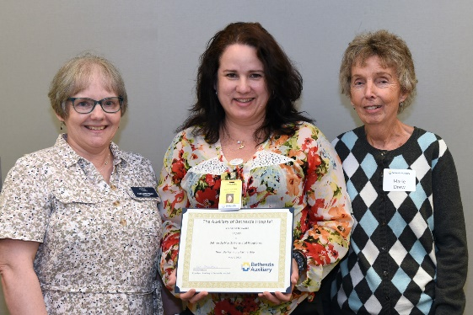
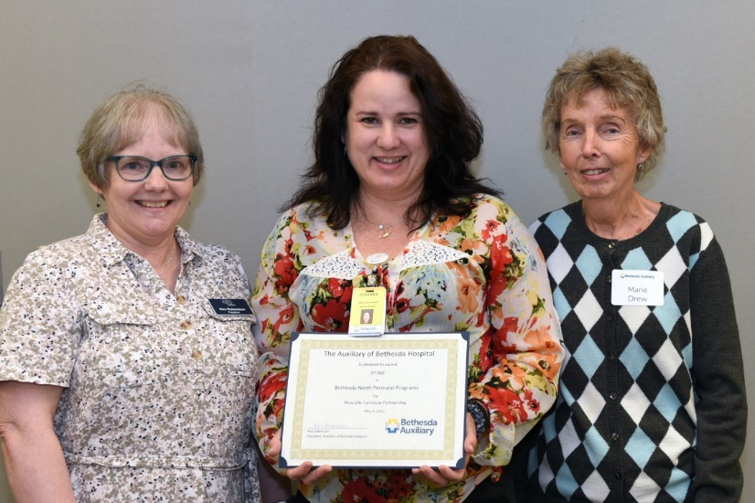
PERINATAL PROGRAMS. Many clients of the Perinatal Clinic do not have furniture. These funds will pay the yearly partnership fee with New Life Furniture and cover of the cost for the delivery of furniture - beds, sofas, tables, etc. for families in need. $6,000

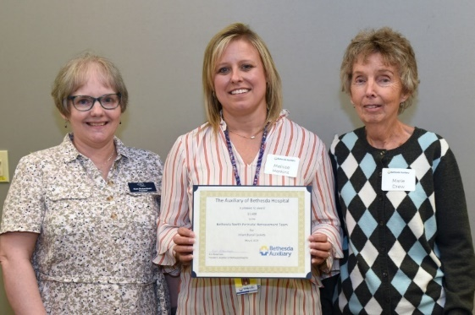
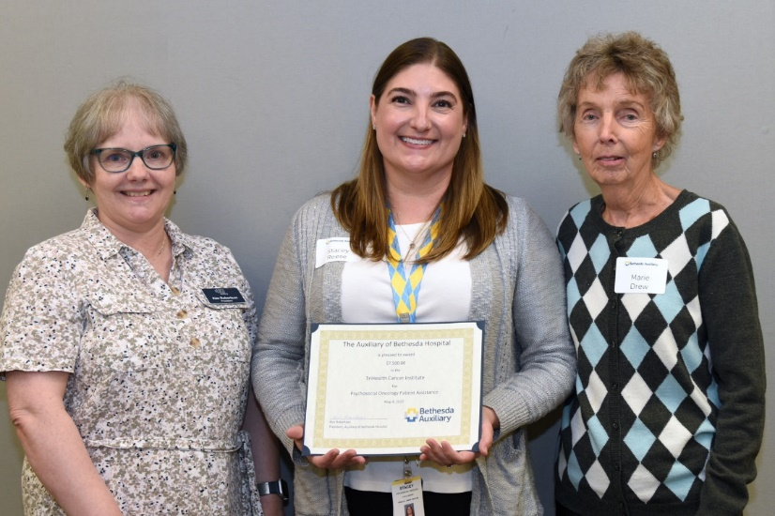
BETHESDA NORTH PERINATAL BEREAVEMENT PROGRAM. In the sad case of infant loss, the Auxiliary is providing funds to purchase small caskets for the respectful burial of miscarried or stillborn babies. This grant of $1,600 will help ease the financial burden for families in their time of grief.

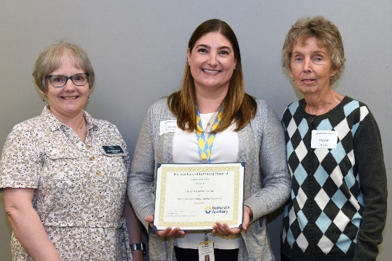
TRIHEALTH CANCER INSTITUTE. $7,500 for Kroger gift cards that can be used for food, medication, and gas for Psychosocial Oncology Indigent Patient Basic Needs. It’s humbling to realize how much a Kroger Gift Card means to someone struggling not only with cancer but financially.

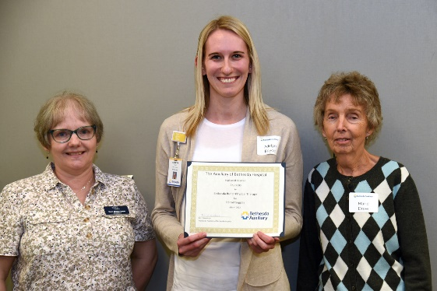
BUTLER PHYSICAL THERAPY will receive $2,250 for Frenzel Goggles which are used to identify vestibular disorder in patients – in layman’s terms these goggles help to diagnose issues that cause dizziness and supports TriHealth in offering the most advanced treatments to patients.

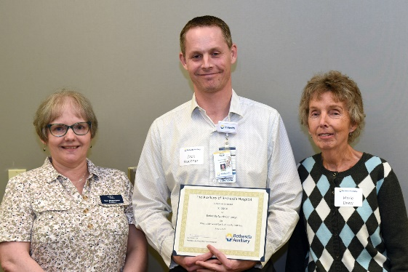
BETHESDA NORTH GUEST SERVICES CONCIERGE DEPARTMENT will be able to purchase disposable wired ear buds for patients. Most of our patients refly on mobile phones and I-pads to communicate with family or to play music or games. Often, conversations and noise from these devices can be heard in the hallways and other patient rooms which can be disruptive. We are providing $1,000 for this project in hopes that it will help maintain a quiet healing environment for our patients.

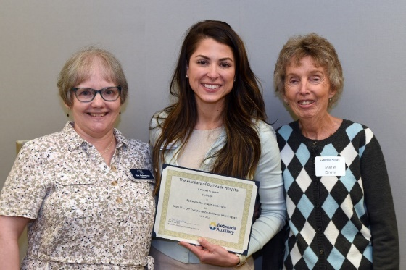
The Auxiliary is funding a pilot transportation project at Bethesda North. Because of Bethesda North’s location, it can be difficult for team members without reliable transportation to get to work. This pilot program will provide a limited number of Uber rides to/from work for team members experiencing temporary transportation challenges. This program will be carefully monitored for use and effectiveness. $6,000

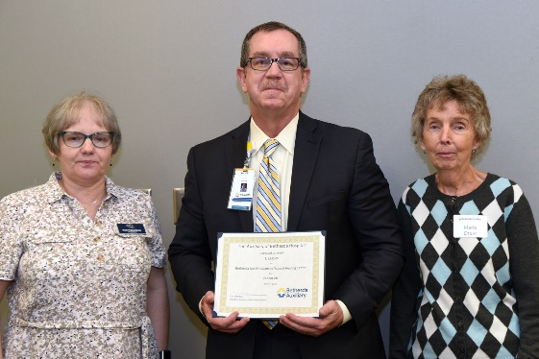
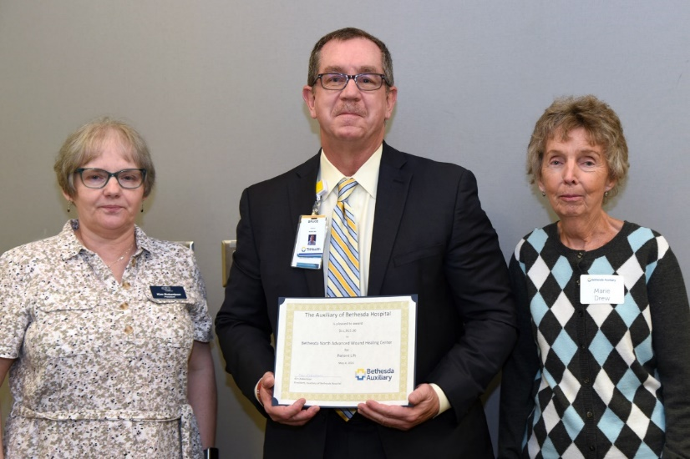
Bethesda has a very busy WOUND CARE CENTER which will soon be moving to a new location within the hospital. We are granting almost $12,000 for a 1,000-pound capacity Patient Lift for the new Wound Care space. This lift will help prevent injuries to patients and caregivers. The Wound Center sees 50 wound care patients/day, ranging in age from 14 months to 100+ years. This patient lift will enable us to manage the movement of our larger patients safetly, without risk of injury to our nursing staff, and enable us to treat our larger patients with care and dignity.
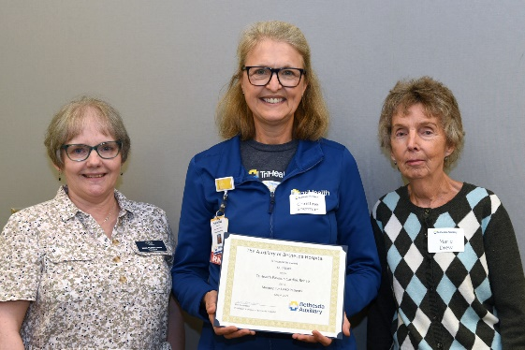
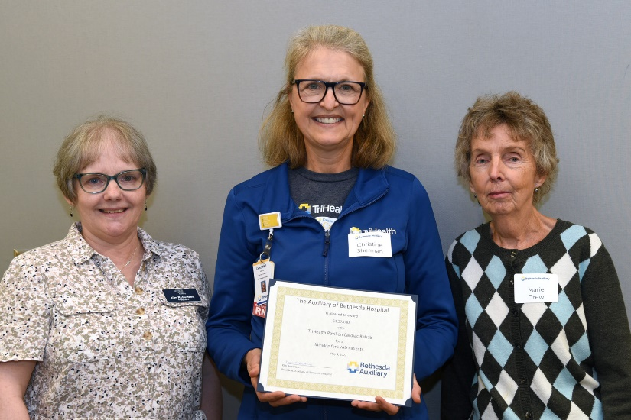
TRIHEALTH PAVILION requested $1,578 for a Minidop for LVAD patients. Bethesda North performed its first LVAD -Left Ventricular Assist Devise - heart procedure recently. When a heart failure patient receives the LVAD, a special piece of equipment is needed for taking a pulse. This doppler will be used for LVAD recipients in rehab at the Pavilion.

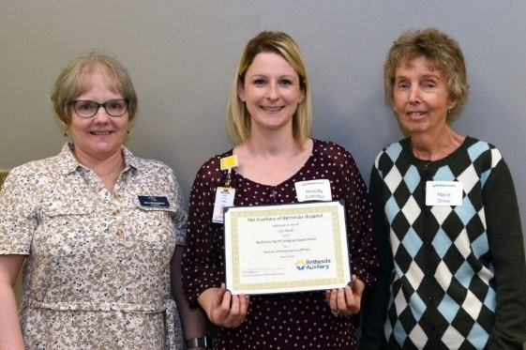
BETHESDA RADIOLOGY has been granted $18,705 is for a Virtual Colonoscopy Insufflator for the Imagining that shortens the length of an exam, provides consistent quality images, and improves accuracy in diagnosis for patients who have had incomplete colonoscopies or who are not a candidate for a conventional colonoscopy.
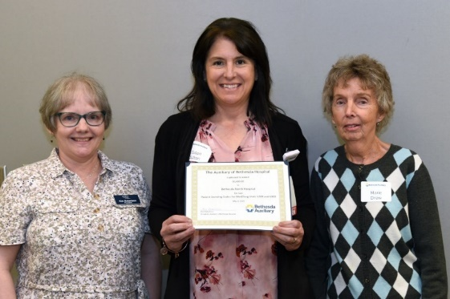
The Auxiliary granted $6,600 for 2 patient standing scales which will be placed on 5200 and 6300 at Bethesda North. These scales are portable and can be moved from room to room. A patient’s weight is measured upon hospital admission and in regular intervals throughout their stay for monitoring nutritional status and safe medication dosage.

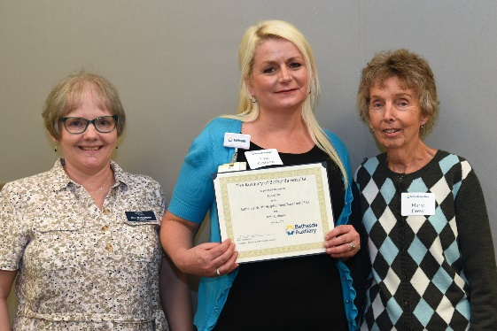
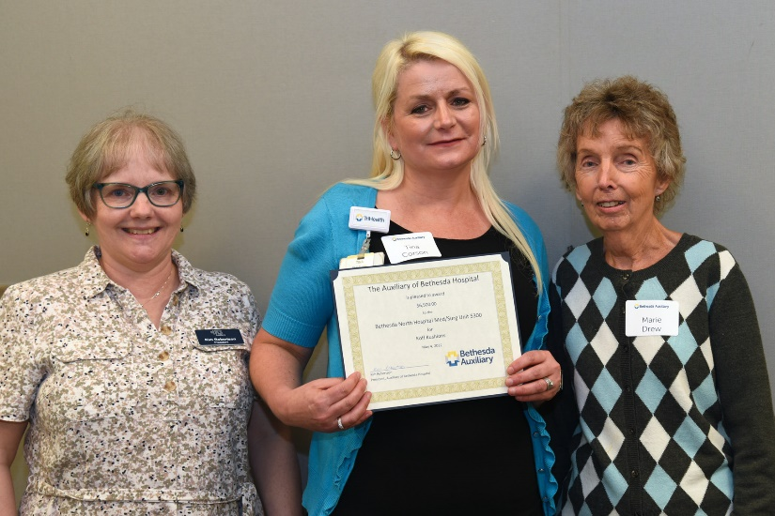
Koff Kushions are a post-operative splint that provide firm, even, and effective sternal support for oncology and surgical patients. The splint supports the incision and surrounding tissues and allows full lung expansion and strong cough with minimal pain. The Auxiliary granted $6500 for this purchase.

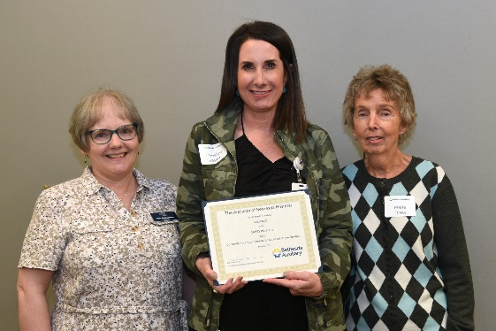
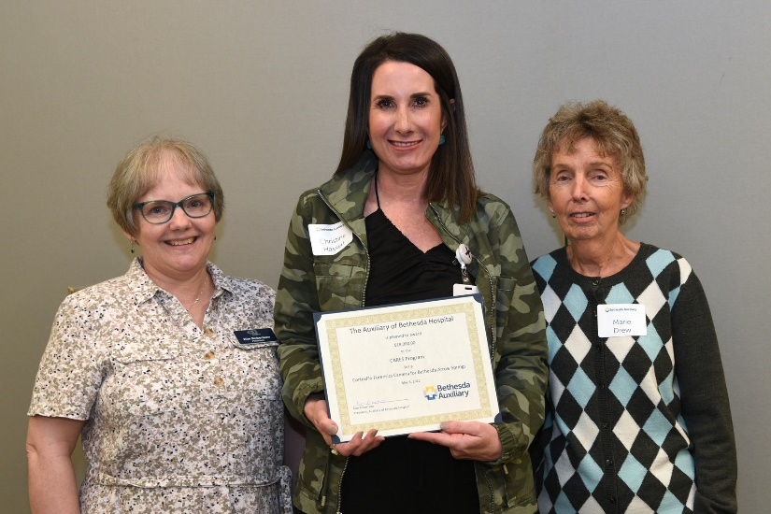
The Center for Abuse, Rape and Emergency Services (CARES) serves survivors of domestic violence, elder abuse, sexual assault, and human/sex trafficking. The Auxiliary is funding the purchase of a CortexFlo forensic camera that can detect bruising and damage that may not otherwise be detected. This $18,000 camera is for Bethesda Arrow Springs.

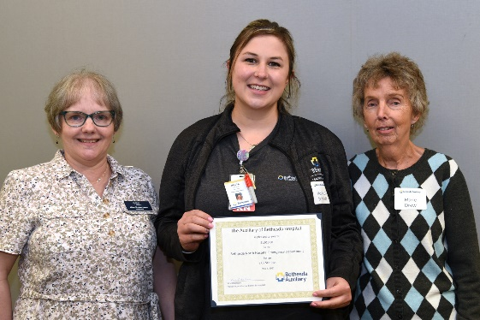
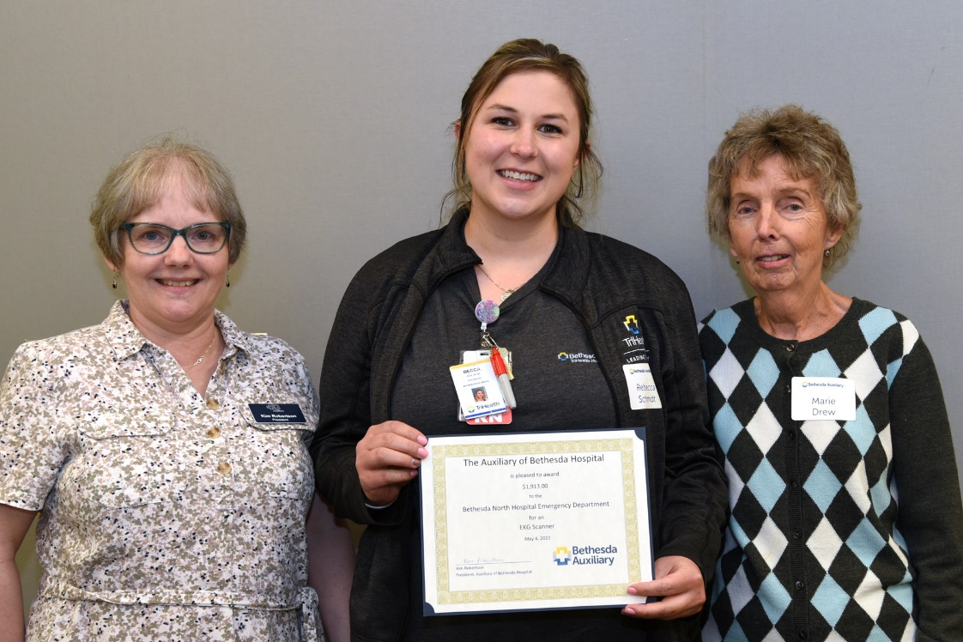
BETHESDA BUTLER EMERGENCY DEPARTMENT applied for and is granted $1,913 for an EKG Scanner which will improve workflow and improve patient safety by auto-populating patient information into the EKG Machine. This expedited process is especially impactful and can be lifesaving when patients are having a heart attack.

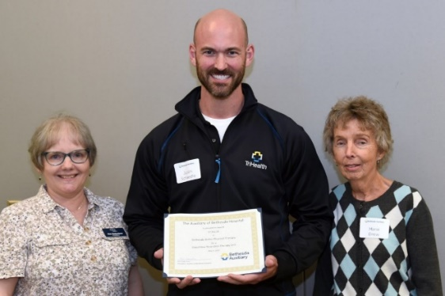
BUTLER PHYSICAL THERAPY DEPARTMENT is receiving $7,942 for a Blood Flow Restriction Therapy Unit. This therapy is a training method for the development of muscle strength and hypertrophy in the athletic and clinical settings. With the purchase of this Blood Flow Therapy unit, Bethesda Butler will be the first TriHealth location and one of only a very few in the area to employ this innovative tool for helping our rehab patients recover.
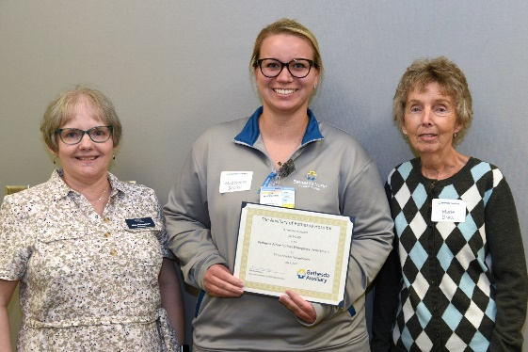
BETHESDA ARROW SPRINGS is granted $8,143 for 3 new Stryker wheelchairs. These top-of-the-line wheelchairs will help with patient comfort and safety and are easy for staff and visitors to operate.

