Auxiliary of Bethesda Hospital Awards College Scholarships
The Auxiliary provides college scholarship opportunities to students who volunteer at Bethesda and to family members of active Auxiliary members. This year, the Auxiliary awarded scholarships in the amount of $1,500 to the following high school seniors:
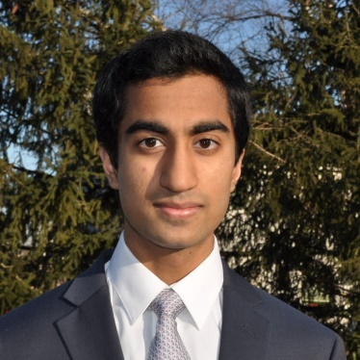
Ravi Bandaru, a student at Mason High School, has volunteered over 370 hours at Bethesda North Hospital as an escort, surgery waiting room assistant, backroom projects helper, front desk assistant, and same day surgery unit assistant. He will attend Penn State in the fall and hopes to become a physician. His supervisor in Same Day Surgery wrote that Ravi’s commitment and passion have made a positive impact on the department.
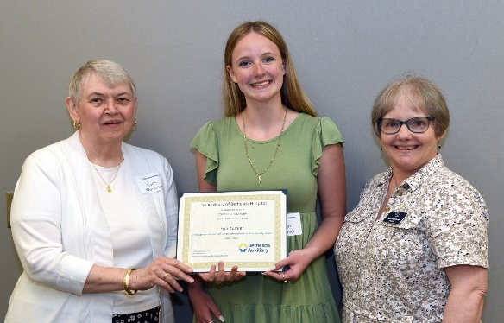
Erin Kumler will graduate from Oak Hills High School and plans to study at Miami University. She will major in biology with hopes to go on to medical school and become a urologist. She volunteers at her church, is on the executive board of the National Honor Society at her school, coaches elementary school cheer, plays golf, and in the words of one of her teachers, is “driven by compassion for others [which] is demonstrated in the many leadership roles she has acquired.”
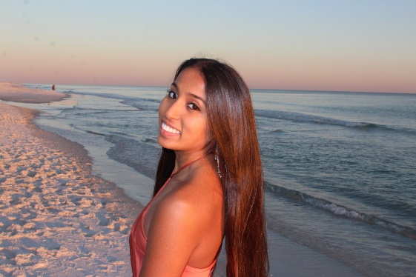
Advika Sumit attends Mason High School and has volunteered at Bethesda North for over 200 hours first in logistics and more recently in the Emergency Department. Her school counselor wrote that more than her outstanding academic achievements, she has dedicated herself to community service. Advika plans to Major in Medical Sciences at the University of Cincinnati and wants to be a Trauma Surgeon or a physician in the emergency department.
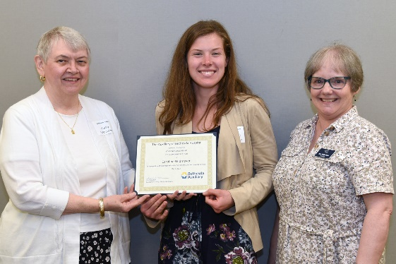
Caroline Widmeyer is a senior at Madeira High School who wants to be a personal trainer and will major in Exercise Science at the University of Cincinnati. Her letters of recommendation mention her as being a model student, pleasant, positive, and kind. She maintains an A grade point average with a part-time job, is an in-demand babysitter, and just completed her first 26 mile run in the Flying Pig Marathon.

